- Many in Lompoc, Santa Maria area (San Antonio Creek), Vandenberg Air Force Base
  - All close to each other
- Reference points on the report maps were often really hard to find on maps, and had to estimate by changing names ex. (Santa Ynez upland groundwater basin to Santa Ynez and San Antonio Creek Valley to San Antonio Creek Trailhead)

Color coding
- Locations marked in yellow often look like this- very broad area displayed on the map, looks like it very likely covers the areas you sent but not 100% sure
  - 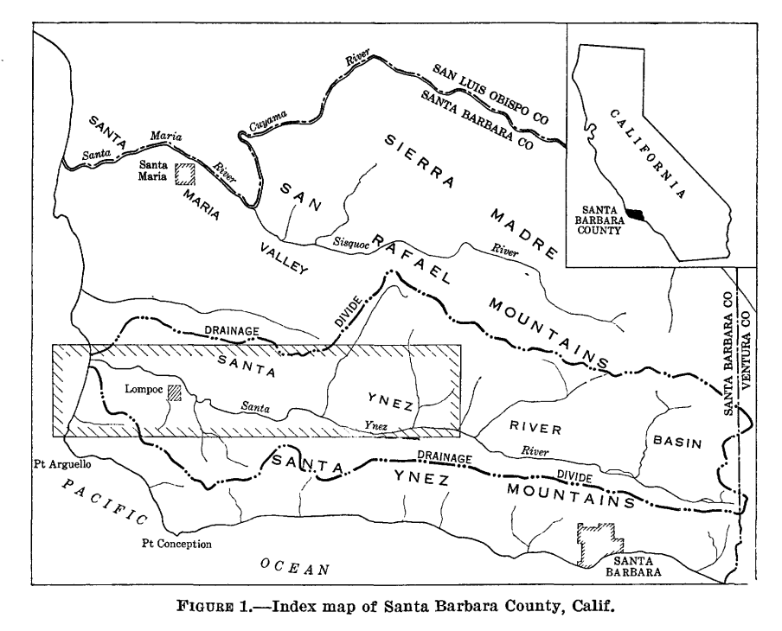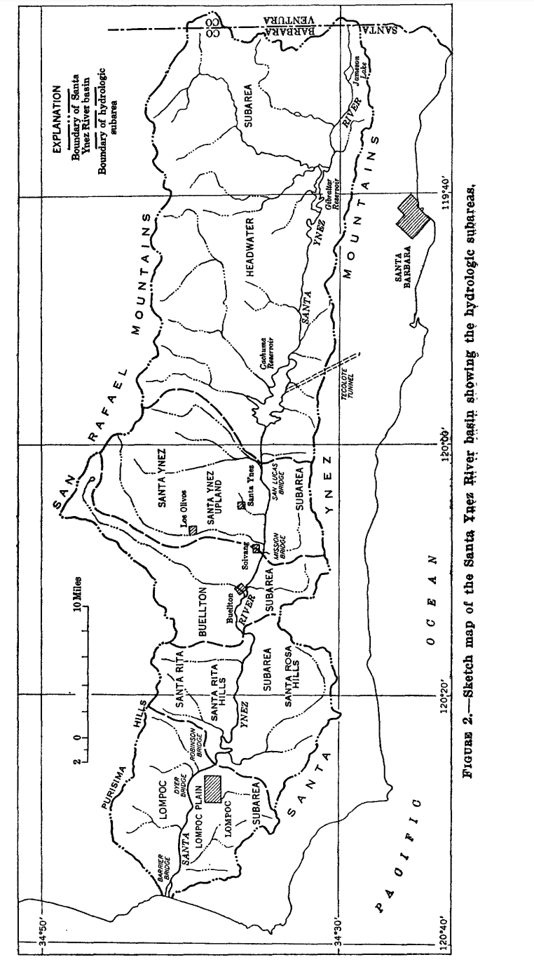
- I marked locations in light green when I could clearly point out both the Goleta and Santa Barbara areas on the map displayed, which I was using for reference because the rivers you sent reach both areas
- Locations were dark green when the names of the creeks are on the pdf
- Locations were marked as red if it did not show on the map and did not have the name of the streams on the pdf

Maria Ygnacio Creek
- Sixth progress report on the cooperative investigation of springs and streamflow in the Tecolote Tunnel area of Santa Barbara County, California https://pubs.usgs.gov/publication/ofr5566
- Water problems of Santa Barbara, California https://pubs.usgs.gov/publication/wsp116
- Flow of springs and small streams in the Tecolote Tunnel area of Santa Barbara County, California https://pubs.usgs.gov/publication/ofr61123
- Third progress report on the cooperative investigation of springs and streamflow in the Tecolote Tunnel area of Santa Barbara County, California https://pubs.usgs.gov/publication/ofr51104
- Geology and ground-water resources of the south-coast basins of Santa Barbara County, California https://pubs.usgs.gov/publication/wsp1108
- Second progress report on the cooperative investigation of springs and stream flow in the Tecolote Tunnel area of Santa Barbara County, Californiahttps://pubs.usgs.gov/publication/ofr50101

San Jose Creek
- Sixth progress report on the cooperative investigation of springs and streamflow in the Tecolote Tunnel area of Santa Barbara County, California https://pubs.usgs.gov/publication/ofr5566
- Water problems of Santa Barbara, California https://pubs.usgs.gov/publication/wsp116
- Flow of springs and small streams in the Tecolote Tunnel area of Santa Barbara County, California https://pubs.usgs.gov/publication/ofr61123
- Third progress report on the cooperative investigation of springs and streamflow in the Tecolote Tunnel area of Santa Barbara County, California https://pubs.usgs.gov/publication/ofr51104
- Geology and ground-water resources of the south-coast basins of Santa Barbara County, California https://pubs.usgs.gov/publication/wsp1108
- Second progress report on the cooperative investigation of springs and stream flow in the Tecolote Tunnel area of Santa Barbara County, California https://pubs.usgs.gov/publication/ofr50101
- Report of the activities of the U. S. Geological Survey during the fiscal year 1950 in cooperation with Santa Barbara County, California https://pubs.usgs.gov/publication/ofr519
  - Almost no data (1 line)

Atascadero Creek
- Third progress report on the cooperative investigation of springs and streamflow in the Tecolote Tunnel area of Santa Barbara County, California https://pubs.usgs.gov/publication/ofr51104
- Geology and ground-water resources of the south-coast basins of Santa Barbara County, California https://pubs.usgs.gov/publication/wsp1108
- Second progress report on the cooperative investigation of springs and stream flow in the Tecolote Tunnel area of Santa Barbara County, Californiahttps://pubs.usgs.gov/publication/ofr50101
- Report of the activities of the U. S. Geological Survey during the fiscal year 1950 in cooperation with Santa Barbara County, California https://pubs.usgs.gov/publication/ofr519
  - Almost no data (1 line)

Mission Creek
- Water problems of Santa Barbara, California https://pubs.usgs.gov/publication/wsp116
  - Includes mission creek discharge and chemical composition
- Geology and ground-water resources of the south-coast basins of Santa Barbara County, California https://pubs.usgs.gov/publication/wsp1108
  - Not sure; “mission ridge” and “mission tunnel”
- Ground-water appraisal of Santa Ynez River basin, Santa Barbara County, California, 1945-52 https://pubs.usgs.gov/publication/wsp1467
  - Not sure; “Mission Bridge”

Goleta Area Covered (not Mission Creek) - from map
- Water levels in observation wells in Santa Barbara County, California, in 1953 https://pubs.usgs.gov/publication/ofr54336
- Water levels in observation wells in Santa Barbara County, California, in 1957 https://pubs.usgs.gov/publication/ofr5836
- Water levels in observation wells in Santa Barbara County, California, in 1956 https://pubs.usgs.gov/publication/ofr5778
- Water levels in observation wells in Santa Barbara County, California, in 1955 https://pubs.usgs.gov/publication/ofr5685
- Ground-water resources of the Santa Ynez upland ground-water basin, Santa Barbara County, California https://pubs.usgs.gov/publication/wsp1467
  - Santa Ynez mountains, not sure if this includes any Goleta streams
- Ground-water appraisal of Santa Ynez River basin, Santa Barbara County, California, 1945-52 https://pubs.usgs.gov/publication/wsp1467
  - Santa Ynez mountains, not sure if this includes any Goleta streams
- Water levels in observation wells in Santa Barbara County, California, in 1955 https://pubs.usgs.gov/publication/ofr5685
- Reconnaissance of the ground-water resources of the Ellwood-Gaviota area, Santa Barbara County, California https://pubs.usgs.gov/publication/ofr68182
  - Ellwood- Gaviota area looks close to Goleta, so maybe?
- Water resources of the Santa Ynez Indian Reservation, Santa Barbara County, California https://pubs.usgs.gov/publication/ofr79413
  - Santa Ynez mountains, not sure if this includes any Goleta streams
- Flow of springs and small streams in the Tecolote Tunnel area of Santa Barbara County, California https://pubs.usgs.gov/publication/wsp1619R
  - Looks like it includes Maria Ygnacio and maybe San Jose

Only SB Covered- from map
- Ground-water reconnaissance of the Santa Barbara-Montecito area, Santa Barbara County, California https://pubs.usgs.gov/publication/wsp1859A
  - Mentioned it used San Jose data for estimating runoff, but doesn’t include it
- Ground-water monitoring at Santa Barbara, California: Phase 1— Coastal monitor-well installation and initial measurements https://pubs.usgs.gov/publication/ofr79923
  - Likely mission

Goleta and SB Covered- from map
- Hydrologic inventory of the Lompoc subarea, Santa Ynez River basin, Santa Barbara County, California, 1957-62 https://pubs.usgs.gov/publication/ofr6642
  - Shows both on location map, but seems to focus on Lompoc area for data

